**CHAPTER 1**

**INTRODUCTION**

An overview of gender, age, and emotion recognition is given in this chapter. The significance of gender, age, and emotion recognition is also discussed, as well as the part that IT plays in these areas.

* 1. **OVERVIEW OF GENDER, AGE AND EMOTION RECOGNITION**

There is now a paradigm shift taking place. For the past few decades, computers have routinely outperformed humans in many daily jobs, and we now rely more and more on them. The whole economy may crash if a bank's database servers went down for any reason and deleted all of its data. We live in an information age where technologies are increasingly used to gather and store data. This data is used by machine learning to discover patterns. It can be used to forecast the weather, assist with credit approval, or suggest a doctor's appointment if an abnormal heartbeat is found.

However, this paradigm shift is currently being driven by the development of deep learning and convolutional neural networks in the area of computer vision, a particular branch of computer science. The rate of image uploads to the internet has been rising significantly over the past ten years. This is driving an increase in computer vision research, along with the fact that high computational power is becoming more widely available to the average user. Now, efforts are being made to research issues that were previously thought to be intractable because of a lack of data or computational capability. These days, cars are capable of driving themselves, detecting pedestrians, and foreseeing or preventing accidents. Even though self-driving cars are a popular issue right now, facial analysis may be even more so. Several functions that are covered by facial analysis that can be used to a variety of situations. For tasks like face detection, pose estimation, age estimation, face recognition, smile detection, gender recognition, and more, there are models available. Machine estimating has frequently surpassed human performance, producing excellent results.

Competitions in artificial intelligence and the IT industry have created a sense of urgency in the desire to research and create the best model. These systems can be used for marketing, security, biometrics, platforms for human-computer interaction, and more. We are gradually moving towards total connectivity with technology, which can now detect and gauge our requirements and traits. In this situation, facial analysis is crucial because nonverbal communication accounts for a large portion of human communication.

* 1. **IMPORTANCE OF GENDER, AGE AND EMOTION RECOGNITION**

After all, facial analysis technologies may transform how we live. When combined with artificial intelligence, it can offer individualized support in every area of life. It can predict our mood when we wake up and, by relating it to our habits, age, and other criteria, recommend the ideal meal for the occasion, the best music to go with that meal, and the ideal outfit, all of which are connected to the weather forecast. Similar to that, when you enter a clothes store, it can automatically recommend the ideal outfit for you based on your age and gender and send a photo of you virtually wearing that outfit to your smartphone. The boring aspects of life will eventually be completely handled by machines. The entire connection and understanding of humans will soon occur, supported by computer vision and facial analysis. In many facial analysis tasks, modern models have really already surpassed human recognition.

* 1. **ROLE OF IT IN GENDER, AGE AND EMOTION RECOGNITION**

Convolutional neural networks (CNNs) are the foundation of all cutting-edge approaches for image-related tasks, including object detection and image categorization. After the introduction of Alex Net by Krizhevsky et al., human face analysis and soft-biometric categorization have grown in popularity. Several computer vision researchers are interested in the topic of such face soft-biometrics, which include age, gender, and facial expression. Deep learning's application to this field has eliminated the necessity for manually created facial features and data pre-processing techniques. D-CNN models have been effectively used for other purposes besides computer vision

* 1. **PROBLEM SPECIFICATION**

In the end, facial analysis technologies may transform how we live. United with facial analysis tools may ultimately change the way we live. It can provide specialized assistance in every aspect of life when paired with artificial intelligence. The best cuisine for the occasion, the greatest music to go with that meal, and the optimum outfit- all of which are linked to the weather forecast- may be suggested by it based on our habits, age, and other factors. It can also predict our mood when we wake up. Any mundane part of life will be capable of being handled by robots. Complete human connection and comprehension will soon be possible thanks to facial analysis and computer vision.

* 1. **PROBLEM STATEMENT**

The potential of deep learning can be combined with the already significant role that mobile phones play in our lives to produce user experiences that astonish and delight people. There isn't a decent Android application that uses the convolution neural network to combine the gender, age, and emotion of a human face for facial recognition. The main objective is to develop a method for determining a person's age and gender from their face, which will remain crucial for pattern recognition and computer vision. Facial expression detection is another crucial component of computer vision, in addition to age estimation. For the simultaneous tasks of age estimation, gender recognition, and emotion detection on face photos, this implementation suggests a new framework. Age, gender, and emotion identification are built into an Android application. The frames from the phone's photo capture are pre-processed and sent to the model to complete this task, and the forecast is then shown as a result.

* 1. **APPLICATIONS**

The following use cases allow for the purpose of gender, age, and emotion recognition:

* Advertisements: In accordance with the age and gender of the caller, the ads may be tailored.
* E-commerce also helps identify suspects in criminal cases, or at the very least, it can reduce the number of suspects because product lists can be changed.
* By monitoring client emotional responses, it can offer insightful feedback for in-store promotions, enabling businesses to better classify their products and deliver better customer care.
  1. **OBJECTIVES**
* To develop a deep learning model that can accurately recognize emotions in individuals according to their age and gender.
* To increase the precision of emotion recognition systems by incorporating age and gender parameters into the analysis.
* To investigate the connection between age, gender, and emotions, and how these variables can affect the accuracy of emotion recognition
  1. **ORGANIZATION OF THE REPORT**

The Project Report has been organized under nine chapters, which are as follows:

**Chapter 1**: Introduces to the main idea of the project. It gives a brief knowledge about the aim and methodology of the same.

**Chapter II:** It includes literature survey of related works

**Chapter III:** Discusses the system requirements that are needed for the project. These include functional requirements, non-functional requirements, user requirements and hardware requirements.

**Chapter IV:** Includes the implementation details of the project, application is explained in detail. It also deals with software approach

**Chapter V:** Includes the system design details which includes flowchart, sequence diagram.

**Chapter VI:** Deals with system testing concepts and the various test cases for the project.

**Chapter VII:** Includes the screenshots of the application and the database.

**Chapter VIII:** Includes the screenshots of the application and the database.

**Chapter IX:** outlines conclusions and future work that can be done

**1.9 SUMMARY**

As this chapter explains, the system was designed with content customization in mind. The system handles age, gender, and mood prediction.

**CHAPTER 2**

**LITERATURE SURVEY**

**2.1 EXISTING SYSTEM**

The suggested layout adheres to the CNN architecture. A deep neural network (DNN) known as a convolutional neural network is frequently used for NLP and image recognition and processing.

Human age, gender, and emotion detection have been extensively studied. This study's main objective is to examine how various deep learning techniques have been applied in recent years to identify age, gender, and emotion. The accuracy of the results has increased significantly with technological improvement and the use of new approaches.

Atanassov et.al [1] Convolutional neural networks known as deep neural networks (DNN) are applied for FER. Initially, these networks are trained with large number of photos of human faces in order to recognize human facial emotions after training phase, the CNN are checked with testing subset of images in order to estimate their accuracy or whether they correctly predict the emotions. Next, the trained CNN can be applied for verification of emotions of not labeled pictures. During the face alignment the background around the face and other non-face elements are removed. Next preprocessing steps are normalization of illumination and facial pose. Variations in the illumination and contrast of the face picture may influence the features extraction, that’s way the normalization algorithms are performed in order to reduce this noise. On the base of facial landmarks and application of pose normalization algorithms the frontal face is generated. Other preprocessing steps are related to scaling the cropped face image to the input size required by the CNN and with the conversion of RGB image to BW format. At the same time, applying the alignment in Google deep leaning face recognition model FaceNet increases the prediction accuracy with 1% up to 99.63%.

I. Lasri, A. R. Solh et.al [2] to train the CNN architecture, they used the FER2013. It was generated using the Google image search API and was presented during the ICML 2013 Challenges. Faces in the database have been automatically normalized to 48×48 pixels. They used OpenCV library to capture live frames from web camera and to detect students’ faces based on Haar Cascades method. The Adaboost learning algorithm chose a few number of significant features from a large set in order to provide an effective result of classifiers. We built a Convolutional Neural Network model using TensorFlow, Keras high-level API. To train our CNN model we splitted the database into 80% training data and 20% test data, then we compiled the model using stochastic gradient descent optimizer. At each epoch, Keras checks if our model performed better than the models of the previous epochs

Mr. Byoung C [3] categorizes approaches into two groups: traditional FER approaches, which include three steps: detection of the face and facial components, and feature extraction, expression classification and novel FER approaches, which include four steps: detection of the face and facial components, and feature extraction, expression classification, and this is a quick study of visual information-based face emotion recognition.

According to a different article by Milad Mohammad et.al [4] Gabor filter are generally used in texture analysis, edge detection, feature extraction. When a Gabor filter is applied to an image, it gives the highest response at edges and at points where texture changes. The image is received and after passing through different layers and the learning process returns a vector with seven modes as output. In fact, these seven modes are: Angry, Disgust, Fear, Happy, Neutral, Sad and Surprise. They first apply a Gabor filter to the images and then convey the output results as inputs to the neural network. The output of the Gabor filter is given to the convolutional neural network.

Mr. M. Mohammadpour [5]. This study's main objective was to build a model based on facial action units (AUs), which CNN first identified and then used to recognize the seven basic emotional states. They used the Cohn-Kanade database and integrated AU to get the best accuracy rate of 97.01, whereas other studies in the literature used a direct CNN and could only manage an accuracy rate of 95.75%.

P. Aiswarya, Manish et.al [6], the datasets required for conducting this experiment includes the detection of face which used the publicly available dataset named FDDB (Face Detection Database and Benchmark) and the estimation of age and gender recognition using the publicly available datasets IMDB-wiki and UTKFace. There is a total of 523,051 images in IMDBwiki dataset and a total of over 20,000 face images in UTKFace dataset. The model works for detection of multiple face detection and age. The range of age which the module detects is from 0-100. It can detect the age of the people within this range of all category like male, female, children etc. This module contains several neural networks which are trained on IMDB-wiki and UTK face datasets. In case of gender, 0 in the label stands for male and 1 stands for female. The emotion model used the public dataset named Fer-2013 for the recognition of emotion of a person Face detection is trained using Darknet, more specifically, the “YOLOv2-tiny” model. You just look once (YOLO) is a state-of-the-art program for detecting objects in real time. It is an implementation of the Keras Functional Framework 2.0. It has AlexNet accuracy with a much smaller footprint.

According to P. Smith C et .al. [7] they used pre-trained CNN models (such as VGG-16 and ResNet) to extract features from facial images. The last fully connected layer was removed, and task-specific layers were added. For gender recognition, softmax regression was used, while regression techniques were employed for age estimation. The performance of the systems was evaluated using standard metrics, and comparisons were made with other methods. The approach aimed to improve the accuracy of gender recognition and the mean absolute error of age estimation using transfer learning with deep CNNs. prediction accuracy was increased by transfer learning using both the VGG19 and by examining the results of modifications to various design strategies and training parameters, VGGFace pretrained models were created. This study also shows that using the appropriate model training strategies can result in high accuracy.

Rabie Helaly et.al [8] they used a dataset with labeled facial images. Their implementation involved designing a CNN architecture with convolutional layers, pooling layers, fully connected layers, and activation functions. The CNN model was trained using the labeled images, optimizing the network parameters through backpropagation. Evaluation was performed on a separate test set, comparing the proposed CNN model with other methods. The results, including accuracy or other metrics, were reported. The authors discussed the strengths and limitations of their approach and concluded by highlighting potential applications and future directions.

S. Arora et.al [9], the main objective of the research presented in this paper is to develop a robust approach for gender recognition using deep learning techniques.

The authors propose a deep learning-based approach that leverages convolutional neural networks for gender recognition. CNNs have demonstrated excellent performance in image-related tasks due to their ability to learn and extract meaningful features from input data. The proposed approach follows a two-step process. In the first step, the authors employ a pre-trained CNN model to extract facial features from input images. These features are then passed through a fully connected layer to obtain gender-specific feature vectors. In the second step, the authors utilize a support vector machine classifier to classify the feature vectors into male or female categories. SVMs are widely used for classification tasks and have shown good performance in various domains. To evaluate the performance of their approach, the authors conduct experiments on publicly available datasets such as the Extended Yale B and AR Face datasets. They compare their approach with existing methods and report the accuracy, precision, recall, and F1-score as evaluation metrics. The authors attribute this improvement to the effectiveness of deep learning techniques in extracting discriminative features from facial images. In conclusion, the paper presents a robust approach for gender recognition using deep learning, specifically utilizing CNNs for feature extraction and SVMs for classification. The experimental results highlight the effectiveness of the proposed approach, indicating its potential for real-world applications.

S. Aydın [10], The research presented in this paper focuses on the classification of complexity levels induced by affective. The author proposes a deep learning-based approach for classifying the complexity levels induced by affective video film clips. The approach involves extracting relevant features from the electroencephalogram (EEG) signals of participants while they are exposed to the video clips. These features are then fed into a deep learning model for classification. To evaluate the performance of the proposed approach, the author conducted experiments using a dataset consisting of EEG recordings from participants exposed to affective video clips. The complexity levels induced by the video clips were classified into low, moderate, and high categories. The approach outperforms traditional machine learning methods, indicating the effectiveness of deep learning in this domain. The experimental results highlight the effectiveness of the proposed approach, indicating its potential for applications in affective computing and mental health assessment.

**2.1 PROPOSED SYSTEM**

The project is a web based application that takes people's images as input. The dataset which is used to train the model is then loaded in the backend. Emotion model is trained using the FER2013 dataset. After the model has been trained, the input image gets processed by the CNN. Initially the input image is resized and converted from the colorful RGB image to greyscale. The image after being processed is converted finally into a 1D array. It is then given to the HAAR Cascade Classifier. It is one of the most popular object detection algorithms in OpenCV. It detects faces and eyes in an image. It uses the cascading window, and it tries to compute features in every window and classify whether it could be an object. Once the faces are detected and extracted, this cropped facial image is passed to the age and gender models to make a prediction. Function for loading the caffe models is written. Caffe supports many different types of deep learning architectures geared towards image classification and image segmentation. It supports CNN, RCNN, LSTM and fully-connected neural network designs. Caffe supports GPU- and CPU-based acceleration computational kernel libraries such as Nvidia cuDNN and Intel MKL. It’s used here for age and gender prediction. It returns the prediction for both age as well as gender parameters. This contains the information of the trained neural network. The model then compares the output with the predefined values for emotions, age and gender and predicts the corresponding age, emotion and gender values.

**CHAPTER 3**

**SYSTEM ANALYSIS AND REQUIREMENTS**

**3.1 FUNCTIONAL SPECIFICATIONS**

The following list summarizes the functional requirements for deep learning-based gender, age, and emotion recognition:

* Image Capture: A mobile device or laptop take a picture of a picture of person’s face to use as input for the prediction.
* Image Processing: For effective recognition, the acquired image needs to be aligned and trimmed.
* Computing gender, age, emotion: To compute the age, gender and emotion of the human in the taken image, the pre-processed image is input to the developed model.
* Show the result: The user must be shown the computed results.

**3.2 NON FUCTIONAL REQUIREMENTS**

The following are the non-functional requirements for the deep learning based gender, age and emotion recognition system:

* Performance and Scalability: The system should operate accurately and efficiently overall.
* Usability: Taking a selfie or screenshot is comparable to how it works.
* Maintainability: If a better dataset is created in the future, the existing dataset can be swapped out for one that is more accurate.

**3.3** **HARDWARE SPECIFICATIONS**

* Intel Pentium 2 or latest Processor
* Dual cores at very least
* Memory of at least 8 GB
* A hard disc of at least 100 GB.’

**3.4 SOFTWARE REQUIREMENTS**

* Flask
* NGROK
* OpenCV-Python
* Tensor flow
* Spyder

**3.5 CHALLENGES**

* People from different ethnic groups have varied facial characteristics, which could slightly change the actual age from the anticipated age, which could lead to misclassifications.
* Wearing glasses could interfere with the traits that are used to classify emotions
* In order to have a better categorization, it is tough and delicate to extract features from one face to another from the database, which may contain grey-scale images of human faces.
* Overfitting is a minor issue that typically arises when using machine learning or deep learning techniques with a dataset that only contains a small number of face photos.

**3.6 SUMMARY**

The problems and the hardware and software components are summarized in this chapter. Each element is crucial, and its implementation requires careful consideration.

**CHAPTER 4**

**SOFTWARE APPROACH**

**4.1 SPYDER**

Spyder is a Python- grounded intertwined development terrain (IDE) that's open- source and cross-platform. The scientific Python mound's most well- known packages, similar as NumPy, SciPy, Matplotlib, Pandas, IPython, SymPy, and Cython, as well as fresh open- source programmes, are all integrated with Spyder. It's distributed under the MIT licence.

Since 2012, a group of scientific Python inventors and the community have been maintaining and constantly enhancing Spyder, which was first designed and erected by Pierre Raybaut in 2009.In addition to supporting interactive tools for data examination and embedding Python-specific law quality assurance and soul-searching tools like Pyflakes, Pylint, and Rope, Spyder is expandable using first- and third- party plugins. Through Anaconda, it's available in Windows, macOS, and major Linux distributions like Arch Linux, Debian, Fedora, Gentoo Linux, openSUSE, and Ubuntu.The Python tapes for PyQt or PySide can be used with Spyder, which uses Qt for its graphical stoner interface. Use of either backend is possible thanks to QtPy, a featherlight abstraction subcaste created by the Spyder design and latterly used by multitudinous other packages.

**4.2 PYTHON**

A high- position, all- purpose programming language is Python. Its design gospel places a strong emphasis on law readability with aid of considerable off- side rule- grounded indentation. Python uses scrap collection and has dynamic typing. It supports a number of programming paradigms, including procedural, object- acquainted, and functional programming, as well as structured programming (especially this). Due to its expansive standard library, it's constantly appertained to as a" batteries included" language.

Python was created by Guido van Rossum in the late 1980s to replace the ABC programming language, and it was firstly made available as Python0.9.0 in 1991. In 2000, Python2.0 was made available. The 2008 release of Python3.0 was a significant update that was only incompletely backwards compatible with former duplications. The final Python 2 release was Python2.7.18, which was made available in 2020.

**4.3 TENSOR FLOW**

A free and open- source software library for artificial intelligence and machine literacy is called TensorFlow. It is applicable in different tasks, mainly in the networked deep learning training and conclusion are given special attention.The Google Brain platoon created TensorFlow for use in internal Google exploration and product. 2015 saw the demoiselle release under the Apache Licence2.0. TensorFlow2.0, the upgraded interpretation of TensorFlow from Google, was launched in September 2019.Python, JavaScript, C, and Java are just a many of the programming languages that support TensorFlow. This rigidity allows for a enormous varieties of operations across multitudinous diligence.

**4.4 NGROK**

ngrok is a burrowing, back delegate that lays out secure coverts from a public endpoint to a locally running organization administration while handling all business for assessment and restoration. Ngrok uncovered unique servers behind NATs and firewalls to the public web over secure coverts.

**CHAPTER 5**

**SYSTEM DESIGN**

**5.1 HIGH LEVEL DESIGN ARCHITECTURE**

Figure 5.1 shows the general high-level architecture of this project. The major goal is to provide a system for estimating the age and gender of human faces, which will remain crucial for pattern recognition and computer vision. Facial expression detection is another crucial component of computer vision, in addition to age estimation.

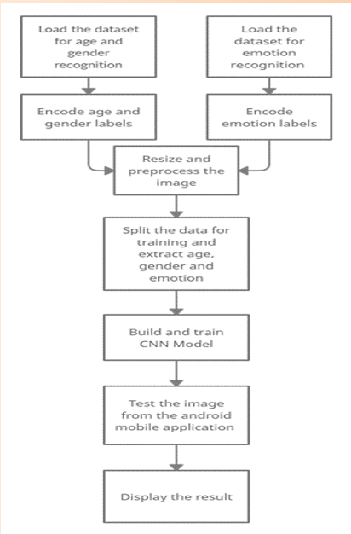

**FIGURE: 5.1 System Architecture**

**5.2 DATA FLOW DIAGRAM**

An image processing pipeline that analyses the user-provided image and feeds it into the classifier is used for the age, gender, and emotion identification. First, the classifier decides whether or not the image is of a person. The results of age, gender, and emotion are then computed. The user sees this outcome in the output.

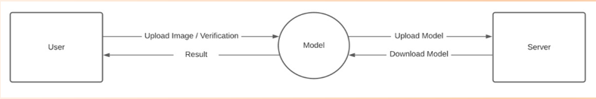

**FIGURE 5.2.1 Data Flow Diagram Processing Pipe Line**

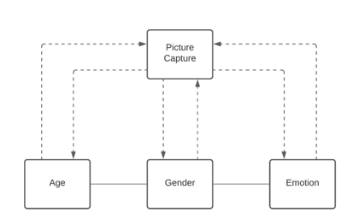

**FIGURE 5.2.2 Age Gender Emotion Model**

**5.3 USE CASE DIAGRAM**

By uploading their facial image, the user can communicate with the model. The model is used to forecast the user's gender, age, and emotion after the image has been submitted to the server. After the computation, the server informs the user of this anticipated outcome.

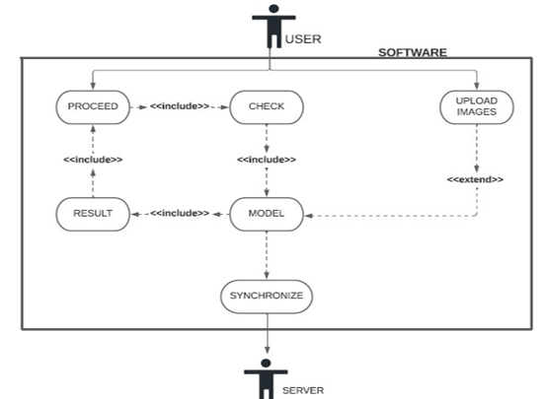

**FIGURE 5.3 Use Case Diagram**

**5.4 SEQUENCE DIAGRAM**

Firstly, the user opens the application. Then, the user can capture or select an image to upload and get the result from the model. This repeats in itself and when the user wants to close the application, before the closing the application checks if there is something to be updated to the remote server.

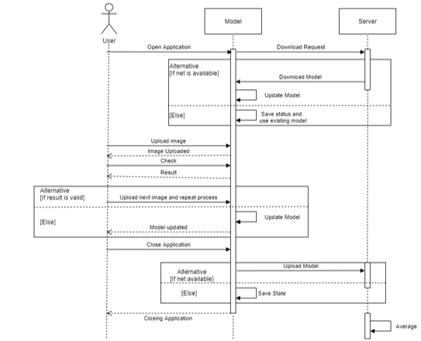

**FIGURE 5.4 Sequence Diagram**

Programming plan and execution is the stage in the programming system at which an executable programming framework is created.

**5.5 CONFIGURATION ISSUES**

• Unfortunate web network it very well may be an issue with modem or switch or poor signals.

• Uncouth picture outline the picture caught ought to contain a human face and ought to be adjusted properly. The individual should not be excessively close nor excessively far (an edge like an identification size print would be pertinent).

• vaticination delicacy-The delicacy of the vaticination is to a great extent reliant upon the casing caught.

• Dynamic URL-The ngrok gives circle liberated from cost however the URL changes with each figure. Accordingly, this URL should be changed in the android activity and the activity must be raised once more.

**5.6 SYSTEM ARCHITECTURE**

The general elevated place armature of this plan is portrayed in Figure4.1. The fundamental intention is to foster an age and orientation assessment framework towards mortal faces which will proceed to hold a significant part in PC vision and example acknowledgment. Piecemeal from age assessment, facial feeling acknowledgment additionally has a significant impact in PC vision. This execution proposes another casing of Convolutional Brain Organization for the contemporaneous assignments old enough assessment, orientation acknowledgment and feeling acknowledgment on face pictures

• Tensor Flow: It is a free and open-source programming library for machine proficiency. It very well may be utilized across a scope of errands however has a specific spotlight on preparing furthermore, finish of profound brain organizations. Tensor flow is a symbolic computation library grounded on dataflow and differentiable programming. It's utilized for both investigation and item at Google. Tensor Flow was created by the Google Cerebrum unit for inward Google use. It was delivered under the Apache License2.0 in 2015

• Flask: Is a miniature web outline written in Python. It's named a micro framework on the grounds that it doesn't bear specific instruments or libraries It has no data set reflection sub caste, structure affirmation, or whatever other elements where prior outsider libraries give normal capabilities. All things considered, Recepticle upholds expansions that can add activity highlights as though they were authorized in Flask itself. Augmentations live for object-social mappers, structure affirmation, transfer running, vivid open validation advances and a few normal edge partnered instruments

. • OpenCV (Open-Source PC Vision Library) is a library of programming capabilities significantly focused on constant PC vision. Right off the bat created by Intel. The library is cross-stage and free for use under the open source Apache 2 Permit. Beginning with 2011, OpenCV highlights GPU speed increase for continuous tasks.

• CAFFE (Convolutional Design for Quick point Inserting) is a profound education outline, right off the bat created at College of California, Berkeley. It is open source, under a BSD permit. It's written in C, with a Python interface. Caffe upholds various kinds of profound proficiency frameworks outfitted towards picture section and picture division. It upholds CNN, RCNN, LSTM and totally associated brain network plans. Caffe upholds GPU and computer processor grounded speed increase computational portion libraries comparative as NVIDIA cuDNN and Intel MKL.

• Ngrok is a burrowing, back delegate that lays out secure coverts from a public endpoint to a locally running organization administration while handling all business for assessment and restoration. Ngrok uncovered unique servers behind NATs and firewalls to the public web over secure coverts.

**5.7 Synopsis**

In this segment implantation of vivid modules associated with the plan of the Orientation, Age also, Feeling Acknowledgment utilizing profound proficiency is investigated.

**CHAPTER 6**

**SYSTEM IMPLEMENTATION**

**6.1 WORKING OF AGE, GENDER PREDICTION**

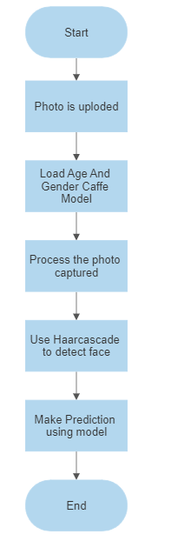

**FIGURE 6.1 Working Of Age And Gender Prediction**

Bringing in cv2, which is an OpenCV library which has the CNN capacities. Tape is caught utilizing the raised in camera. Information can be changed like usb camera connected. Haar cascade model is utilized to descry faces and eyes in a picture. Recently, the level and scope of the edge is set. Capability for stacking the caffe models is composed. It returns the variable of both the models. These lines were downloaded from the Kaggle site. This framework was presented by two Israel experimenters, Gil Levi and Tal Hassner in 2015. This contains the data of the prepared brain organization (prepared model). Both. Caffe model lines are the model lines. The reasoning lines characterize the layers in the brain organization, each subcaste's bits of feedbacks, works and usefulness. The tape caught is reused progressively to descry the appearances utilizing the Haar cascade**.**

**6.2 WORKING OF EMOTION PREDICTION**

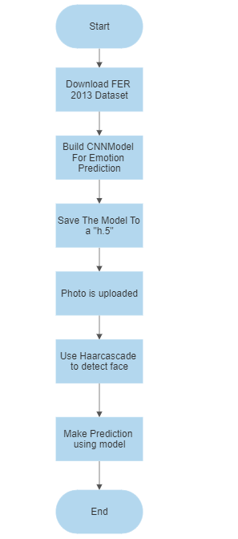

**FIGURE 6.2 Working Of Emotion Prediction**

The FER2013 is used to train the emotion model. The grayscale face images in the FER2013 dataset (facial expression recognition) measure 48 by 48 pixels. The photos are equally spaced apart and centered. This dataset comprises of the seven facial emotion categories of anger, contempt, happiness, sadness, and surprise. The dataset has been downloaded. Extract it into a data folder with distinct directories for training and testing. Create the training and validation generators from scratch. Create the architecture for the convolution network. Compile and train the model, then finish. Model weights should be saved as a ".h5" file. The bounding boxes of the face in the webcam are detected using OpenCV Haar cascade xml, and emotion is predicted using the trained model.

**6.3 WORKING OF THE JAVASCRIPT COMPONENT WRITTEN**

A picture can be chosen or clicked using the upload button. Once the image has been chosen, the "Predict and Suggest" button will appear. Clicking it will cause the computation to be run at the remote workspace, and the predicted outcome will then be shown in the appropriate manner.

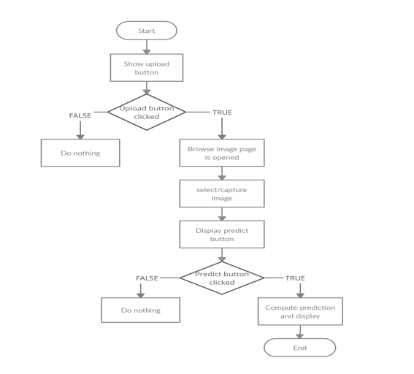

**FIGURE 6.3 Working Of The JavaScript Component Written**

**6.4 IMPLEMENTATION OF FLASK'S WEB APPLICATION**

To render HTML pages and make it possible for the Python code (used to make predictions) to interface with the HTML pages without any issues, the Flask application was developed. The web pages are deployed using NGROK for testing reasons. It is a tunneling reverse proxy that builds safe tunnels between a public endpoint and an active local network service while capturing all traffic for replay and analysis. The upload button can be used to either pick or click an image after the HTML page has been produced. Once the image has been chosen, the "Predict and Suggest" button will appear. Clicking it will cause the computation to be run at the remote workspace, and the predicted outcome will then be shown in the appropriate manner.

**CHAPTER 7**

**SYSTEM TESTING**

**7.1 INTRODUCTION**

After rendering, the testing phase is carried out to find all crimes, give quality assurance, and guarantee the software's responsibility. The system's success is dependent on testing. The software that's going to be tested is run through a set of test cases, and the system's geste during those test cases is looked at to see if it's working as anticipated. It goes without saying that the test cases play a pivotal part in determining whether or not testing reveals crimes.

**7.2 UNIT TESTING**

Unit testing is a degree of programming testing where individual unit’s corridor of a product are tried. The ideal is to insure that each element of the software works as intended. A unit is the lowest software element that can be tested. It typically has one or a couple of sources of word and typically a solitary result. A single program, function, procedure, etc., can be a unit in procedural programming. A system is the lowest unit in object- acquainted programming. It can be a member of a base or super class, an abstract class, or a deduced or child class. Some treat a module of an operation as a unit.

**7.3** **THE ADVANTAGES OF UNIT TESTING INCLUDE:**

• Unit testing supplements trust in changing keeping up with law. We'll be suitable to snappily identify any blights brought about by the change if good unit tests are written and run each time law is changed. Also changes to any law have a lower unintended impact if they're formerly made lower interdependent in order to enable unit testing.

• Canons can be used more times. Modular canons are necessary for unit testing to be possible. As a result, it's simpler to exercise canons.

• Development is quicker. However, you write your law and do the vague" inventor test"( you set breakpoints, open the GUI, If you do not have unit testing. still, compared to system testing or acceptance testing, the trouble needed to identify and address blights discovered during unit testing is significantly lower.

• Compared to blights set up at advanced situations, the cost of fixing a disfigurement set up during unit testing is lower. When a disfigurement is discovered during acceptance testing or when the software is live, the costs — time, trouble, destruction, demotion — are compared. Debugger is simple. Only the most recent changes need to be amended when a test fails. When testing at advanced situations, it's necessary to examine changes made over a number of days, weeks, or months.

• Coding is more reliable. I suppose there's compelling reason need to make sense of this for a rational individual.

**7.4 INTEGRATION TESTING**

When performing software testing at the integration testing level, numerous software components are combined and assessed as a whole. This level of testing aims to find problems with the interactions between integrated units. Integration testing is aided by the use of test drivers and test stubs.

The following are definitions of integration testing:

* Testing is carried out to reveal flaws in the interactions and interfaces between integrated systems or components.
* Component integration testing is testing done to find issues with how integrated components interact and interface with one another.
* System integration testing includes testing the interfaces to external organizations as well as the integration of systems and packages.

**CHAPTER 8**

**RESULTS AND DISCUSSIONS**

**8.1 RESULTS**

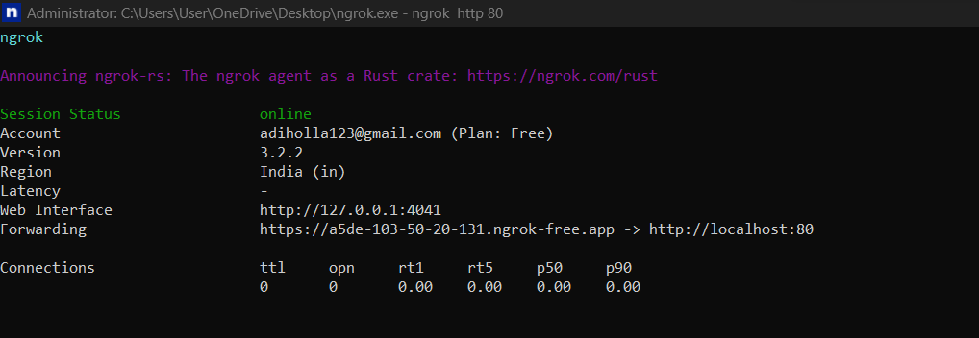

**Figure 8.1.1 Ngrok Execution Window**

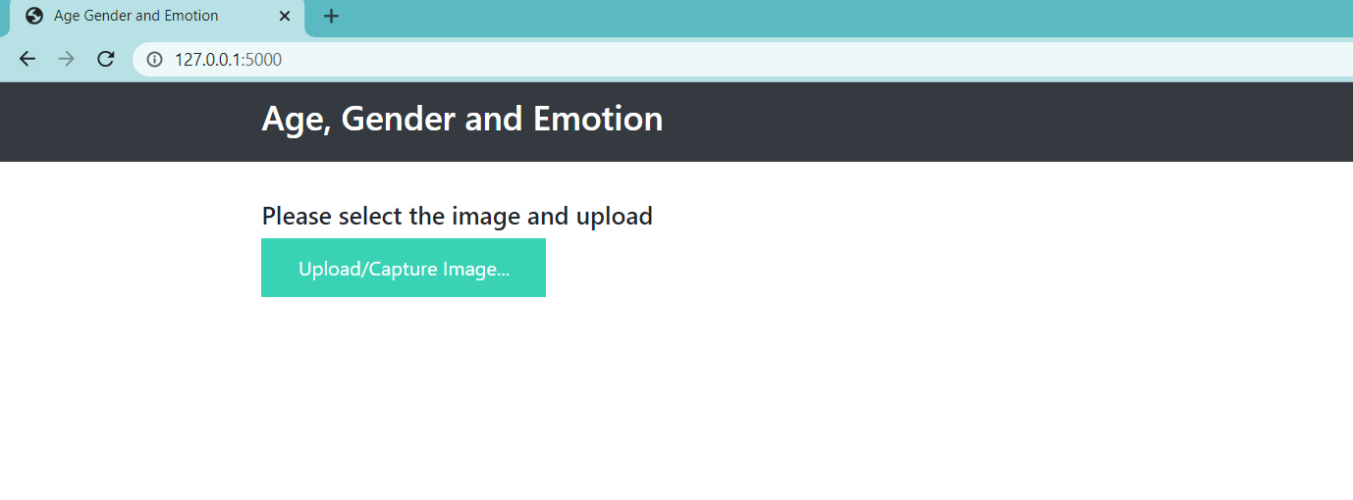

**Figure 8.1.2 Flask Output Home Page**

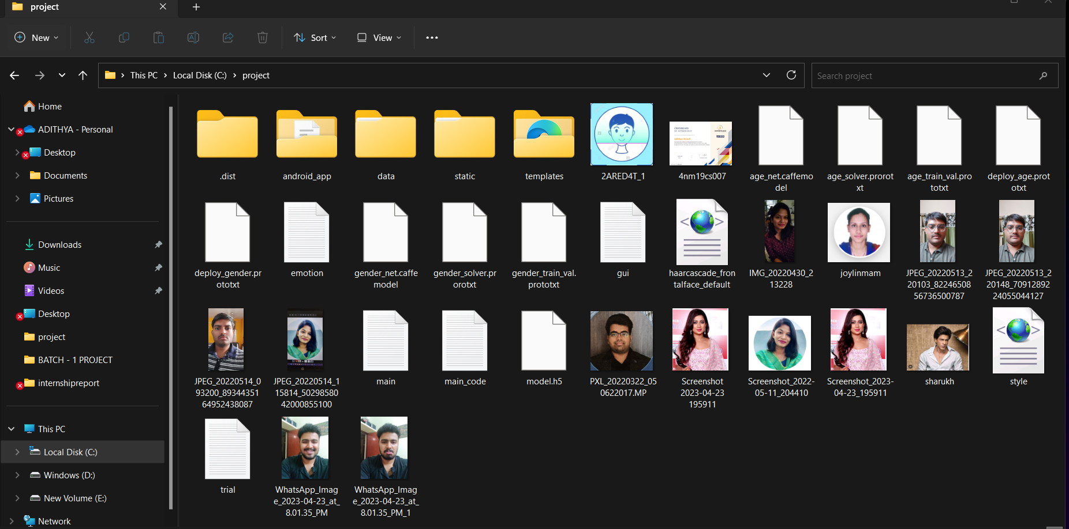

**Figure 8.1.3 Image Browsing Window**

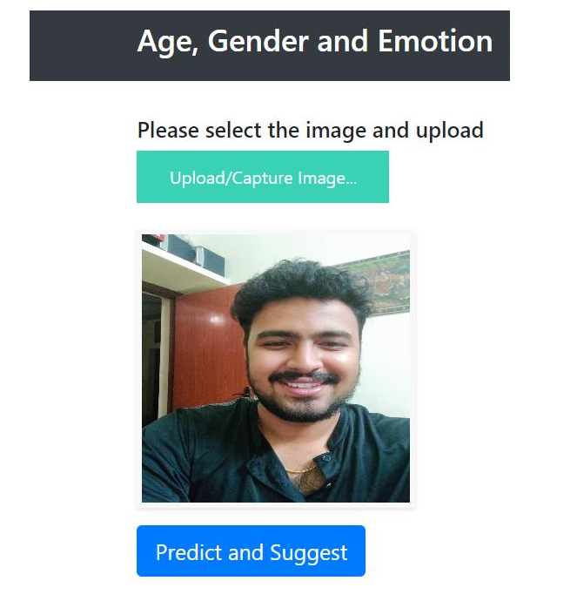

**Figure 8.1.4 Browsed Image View**

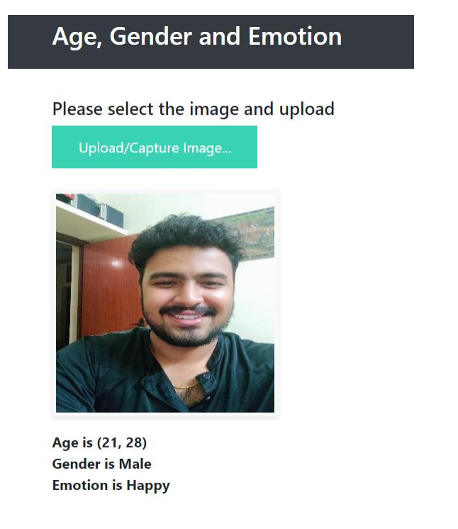

**Figure 8.1.5 Displaying Predicted Result**

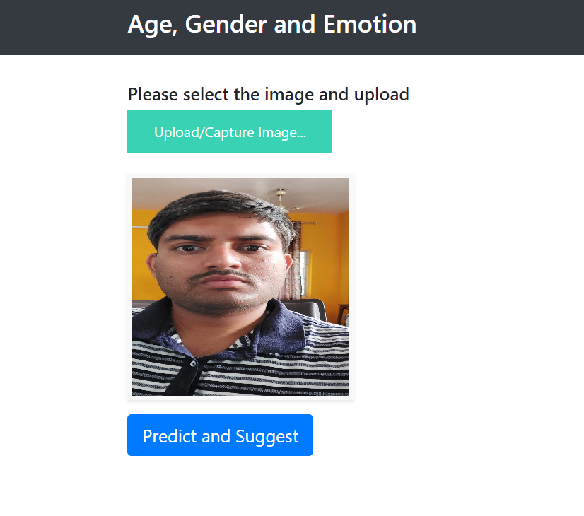

**Figure 8.1.6 Browsed Image View**

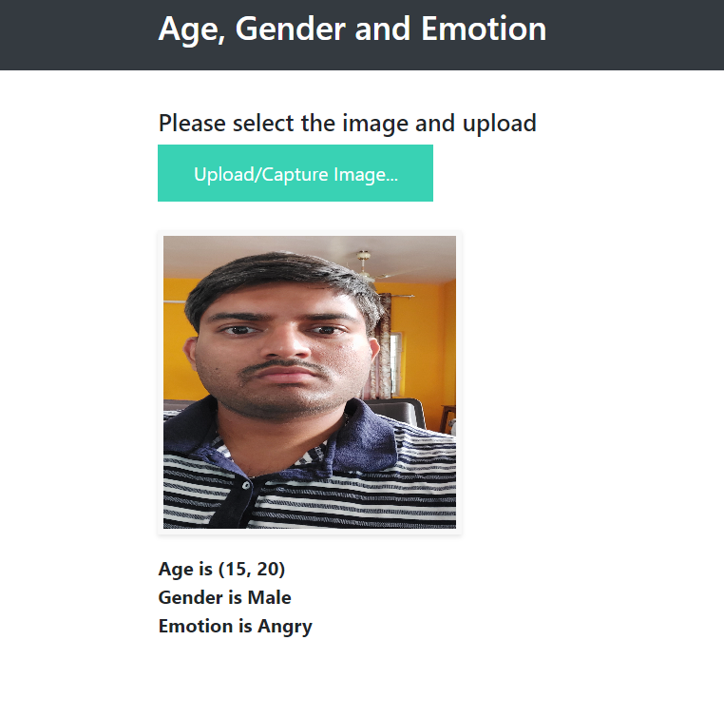

**Figure 8.1.7 Displaying Predicted Result**

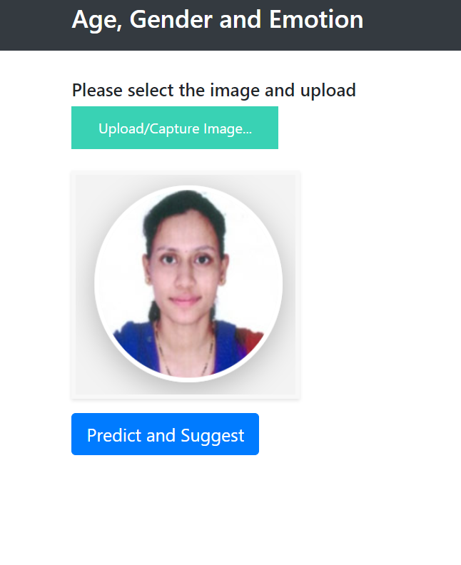

**Figure 8.1.8 Browsed Image View**

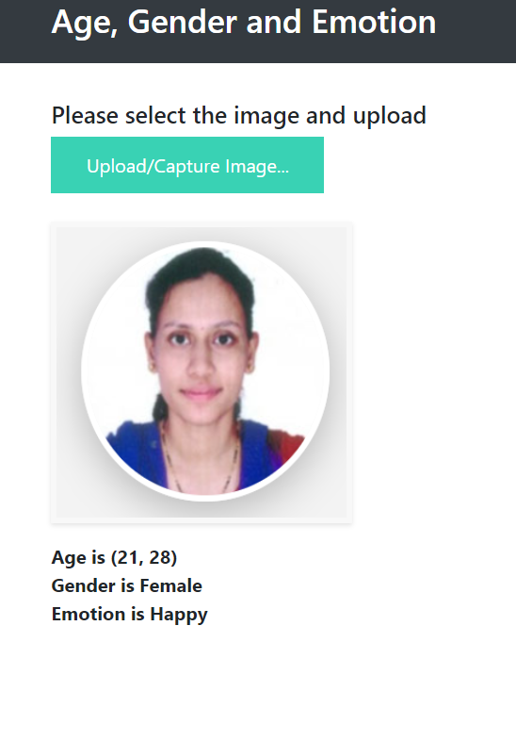

**Figure 8.1.9 Displaying Predicted Result**

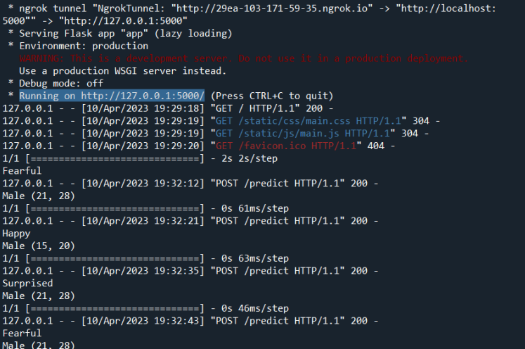

**Figure 8.2.0 Python Console After Prediction**

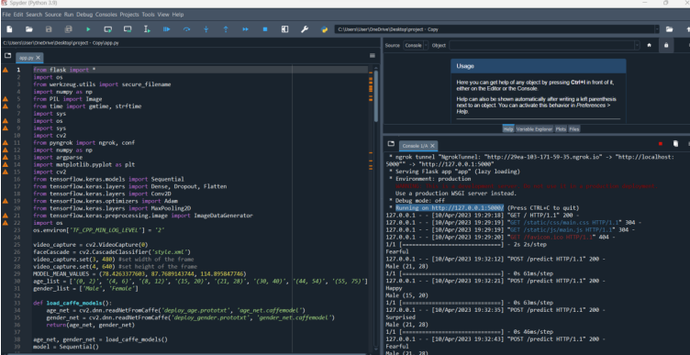

**Figure 8.2.1 Code Snippets**

**8.3 DISCUSSIONS**

Gender, age and emotion recognition has relevant use in various software and hardware. Its use can help provide specialized advertisements that targets the mood of the user. If the user is angry, the website can show advertisements of food or other pleasant activities that calm us down. Further it has more use in security systems that are used in airports or banks and even prisons. Criminals can be monitored from their cells. It can predict the emotion of the suspects in the vicinity of the premise which helps in arriving at further conclusions of their actions. A person who has intentions to rob a bank might be scared thinking if he might get caught. By taking the image of him and using the proposed system, it can detect the emotion, gender and age which will help in understanding future actions of the suspect.

**CHAPTER 9**

**CONCLUSION AND FUTURE SCOPE**

The suggested frame has contemporaneous, quick, and effective gender, age, and emotion recognition capabilities. As a result, both a Beaker operation to emplace web operations and an Android operation are created. People from different ethnical groups have varied facial characteristics, which could slightly change the factual age from the awaited age, which can lead to misclassifications. By snooping with the learned features, the use of specs may have an impact on emotion bracket.

The sigmoid function was employed by the models in our exploration, but we enforced it far more effectively by replacing it with a ReLU function, which boosts both speed and delicacy.

We can observe a sizable enhancement in age and gender discovery delicacy when we differ our design and perpetration with the other executions listed in our exploration. Our programme also mixes gender, age, and emotion to produce results that are specifically acclimatized to each stoner's gender, age, and emotion. Our model's effective delicacy for age, gender, and emotion is 93, 80, and 85, independently.

Incipiently, applying this approach to a performing business service would be interesting. This design can be used to outline culprits and help in catching them either as they're committing the crime or after they've escaped, as well as to customize announcements and content on social media, product rosters in e-commerce, and OTT(over-the-top) content in the entertainment assiduity

**REFERENCES**

1. Atanassov and D. Pilev, "Pre-trained Deep Learning Models for Facial Emotions Recognition," 2020 International Conference Automatics and Informatics (ICAI), 2020, pp. 1-6, doi: 10.1109/ICAI50593.2020.9311334.
2. I. Lasri, A. R. Solh and M. E. Belkacemi, "Facial Emotion Recognition of Students using Convolutional Neural Network," 2019 Third International Conference on Emotion Recognition By Inclusion Of Age And Gender Parameter By Deep Learning Dept. of CSE, NMAMIT, NITTE Page 21 Intelligent Computing in Data Sciences (ICDS), 2019, pp. 1-6, doi: 10.1109/ICDS47004.2019.8942386.
3. Ko, Byoung C. 2018. "A Brief Review of Facial Emotion Recognition Based on Visual Information" Sensors 18, no. 2: 401.
4. M. M. Taghi Zadeh, M. Imani and B. Majidi, "Fast Facial emotion recognition Using Convolutional Neural Networks and Gabor Filters," 2019 5th Conference on Knowledge Based Engineering and Innovation (KBEI), 2019, pp. 577-581, doi: 10.1109/KBEI.2019.8734943.
5. M. Mohammadpour, H. Khaliliardali, S. M. R. Hashemi and M. M. AlyanNezhadi, "Facial emotion recognition using deep convolutional networks," 2017 IEEE 4th International Conference on Knowledge-Based Engineering and Innovation (KBEI), 2017, pp. 0017-0021, doi: 10.1109/KBEI.2017.8324974.
6. P. Aiswarya, Manish and P. Mangalraj, "Emotion recognition by inclusion of age and gender parameters with a novel hierarchical approach using deep learning," 2020 Advanced Communication Technologies and Signal Processing (ACTS), 2020, pp. 1- 6, doi: 10.1109/ACTS49415.2020.9350479.
7. P. Smith and C. Chen, "Transfer Learning with Deep CNNs for Gender Recognition and Age Estimation," 2018 IEEE International Conference on Big Data (Big Data), 2018, pp. 2564-2571, doi: 10.1109/BigData.2018.8621891.
8. R. Helaly, M. A. Hajjaji, F. M'Sahli and A. Mtibaa, "Deep Convolution Neural Network Implementation for Emotion Recognition System," 2020 20th International Conference on Sciences and Techniques of Automatic Control and Computer Engineering (STA), 2020, pp. 261-265, doi: 10.1109/STA50679.2020.9329302
9. S. Arora and M. P. S. Bhatia, "A Robust Approach for Gender Recognition Using Deep Learning," 2018 9th International Conference on Computing, Communication and Networking Technologies doi: 10.1109/ICCCNT.2018.8494194.

[10] S. Aydın, "Deep Learning Classification of Neuro-Emotional Phase Domain Complexity Levels Induced by Affective Video Film Clips," in IEEE Journal of Biomedical and Health Informatics, vol. 24, no. 6, pp. 1695-1702, June 2020, doi: 10.1109/JBHI.2019.2959843.